

|  |
| --- |
| 02. Introduction and Background |

In January 2015 the Joint Committee asked Welsh Health Specialised Services Committee (WHSSC) to co-ordinate a collaborative commissioning project to be overseen by the All Wales Gender Dysphoria Partnership Board (now known as the All Wales Gender Identity Partnership Group). The outcome of the Task and Finish Group (a Gender Variance clinical pathway task and finish group, a sub group of the All Wales Gender Dysphoria Partnership Board), was set up in April 2016 to support work to consider an All Wales Gender Identity Service for Wales. The outcome of that work was the presentation of a Non- Financial Outcome appraisal for Gender Identity Services Care Pathway in Wales to the Joint Committee on the 22nd November 2016 who accepted a set of recommendations. One of the recommendations from that work was to develop interim arrangements and continuity of care for existing Welsh patients whilst further work took place to secure a longer term model/pathway. This was needed not only to consider the rising waiting times at Gender Identity Clinics, but to also address ongoing problems patients are facing accessing hormone prescribing as part of their treatment pathways.

In 2017 the Health Minister, made an announcement at Pride Cymru to say that the Welsh Government were going to set up a gender service in Wales. The resulting business case, presented by Cardiff and Vale UHB, was submitted to Welsh Government and WHSSC in February 2018; consequently the Welsh Gender Service (WGS) was established.

The service was initially set up as an interim service, with the proviso that only non-complex patients were to be assessed, and endorsed, for hormone replacement therapy. The first phase of setting up the interim adult gender pathway allowed the service to start seeing non-complex patients in September 2019; surgical assessment and surgery were still to be performed in London at that time. A clinical lead and two clinicians were employed, with the clinical lead training colleagues to undertake gender assessments.

In April 2019, ~400 patients were transferred to Wales from the Tavistock and Portman Gender Identity Clinic; the waiting list position is now over 1000; the backlog and the recurrent demand is key to the infrastructure requested. The service has received new referrals, patients from the old WHSSC Commissioning Policy for Adult Gender Identity Services, private patients and graduates from the Gender Identity Development Service (GIDS – patients <18 years old); these have far exceeded the expected 365 referrals in a year (data provided by the Tavistock and Portman GIC)

Picture of growth nationally in the UK:

* At Charing Cross in London, the oldest and largest adult clinic, the number of referrals has almost quadrupled in 10 years, from 498 in 2006-07 to 1,892 in 2015-16.
* A clinic in Nottingham reported a 28-fold increase in referrals in eight years, from 30 in 2008 to 850 in 2015. It expected this to increase to more than 1,000 referrals during 2016.
* The Laurels clinic in Exeter has seen a 20-fold increase in referrals in a decade, from 31 in 2005-06 to 636 in 2015-16.
* Referrals to Sheffield’s clinic went up from eight in 1998 to 301 in 2015, while a clinic in Daventry, Northamptonshire, has had a five-fold increase in the past year alone, up from 88 referrals in 2014-15 to 466 in 2015-16

<https://www.theguardian.com/society/2016/jul/10/transgender-clinic-waiting-times-patient-numbers-soar-gender-identity-services> (accessed 22nd June 2020)

|  |
| --- |
| 03. Summary Strategic Context |

The model proposed within this document outlines the requirements for a National Gender Identity Service for the population of Wales. Caring for People; Keeping People Well and WHSSC commissioning intentions/policy – equitable service for all Wales etc. is why we exist as a UHB, with a vision that a person’s chance of leading a healthy life is the same wherever they live and whoever they are.

Current provisions for access to transgender services for an adult within Wales has improved with the implementation of the Welsh Gender Service, but the location is still inequitable to those in North Wales and is still a very lengthy process.

It is acknowledged that further work is necessary to ensure an equitable and sustainable service for Wales.

Key areas of improvements are:

* Staff clinic to levels that can meet the demand on the service
* Create a satellite clinic that can facilitate North Wales
* Further establish Local Gender Teams levels of expertise
* Work to establish holistic pathway that takes in to account all areas of transition

|  |
| --- |
| 04. Summary Current Service Provision |

# Current Model/Pathway

The current model, as set out by pathway CP182; this has been modified to show that only forensic referrals now go to London (Diagram 1).

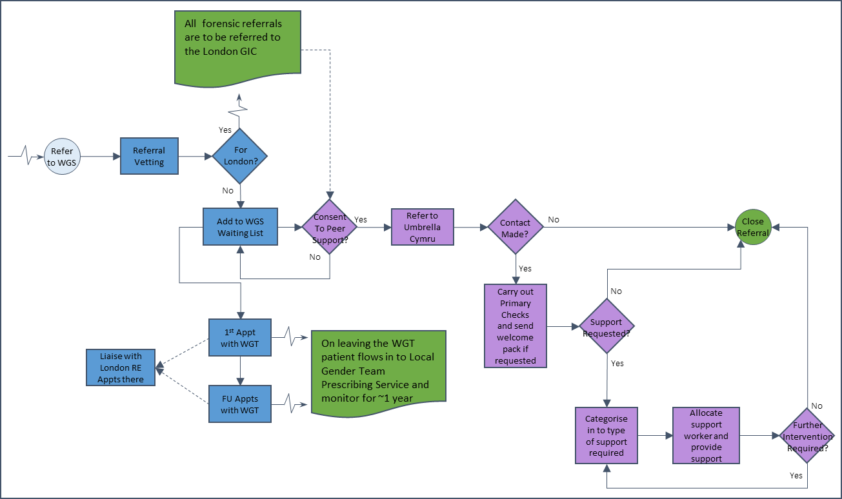

#### Diagram 1

# Current Activity

As a result of the COVID-19 pandemic, in quarter 1, a new process was developed for staff to provide remote gender assessments, follow up appointments and psychological therapy. As expected, activity was affected by this but is now beginning to recover (Table 1). Note for table 1, core activity is based on current job plans, scheme activity is anything funder over and above that (this principle is carried througout this paper)



#### Table 1

|  |
| --- |
| 05. Case for Change |

# Demand

Due to the transfer of the waiting list, it is not possible to calculate demand using the traditional method (activity + waiting list change), so for the purpose of this paper, new referrals received has been used.

As mentioned in the introduction, the demand for gender services has increased exponentially over the last 5 to 10 years, with more and more people seeking access. There are many possible explanations, such as an increase in the prevalence of the condition, change in help-seeking behaviour, recent cultural shifts which could influence people to seek treatment (Fielding and Bass (2018)). If nothing were to change, the service would never be in a position to meet its demand; if left untreated, gender dysphoria can cause extreme distress and dramatically increase the risks of self-harm and suicidality (Ellis et al (2015)).

Graph 1 shows the number of referrals in Wales from September 2017 to May 2020

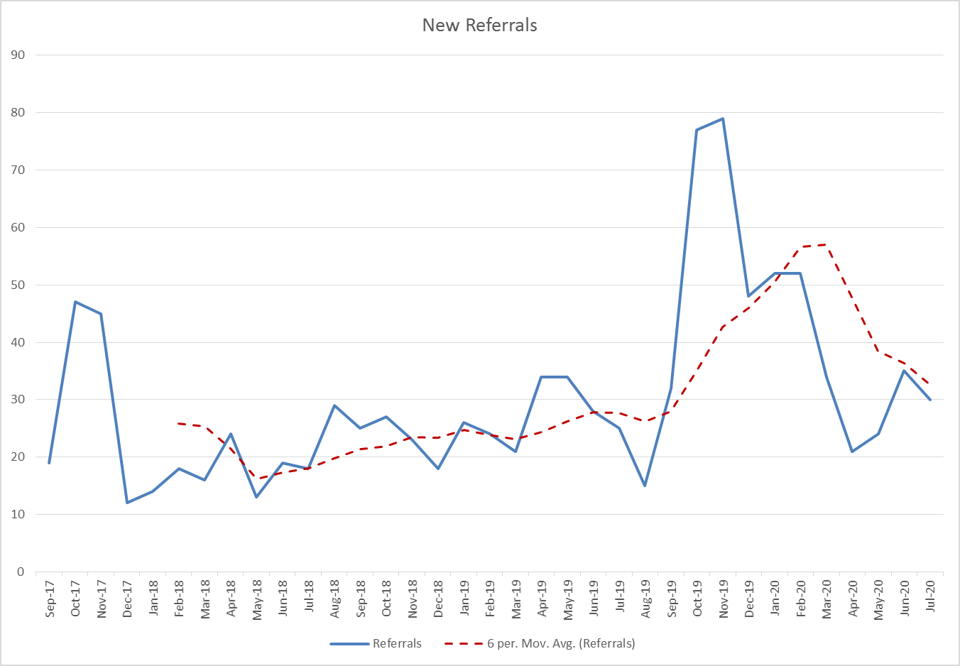

#### Graph 1

Transgender people face unique stressors and vulnerabilities including pervasive discrimination, prejudice, rejection, and violence (Hamison (2019), therefore their ability to access timely care impacts on their safety and well-being. Suicidal ideation in trans people who are planning medical transition but have not yet begun is 55%, in those who have begun it is 41% and in those who have medically transitioned is 23% (Bauer, Greta R., et al (2013)); this clearly shows the impact of providing timely medical intervention for the trans population of Wales.

Bailey et al (2014) revealed high rates of suicidal ideation (84 per cent lifetime prevalence) and attempted suicide (48 per cent lifetime prevalence). A supportive environment for social transition and timely access to gender reassignment, for those who required it, emerged as key protective factors. Subsequently, gender dysphoria, confusion/denial about gender, fears around transitioning, gender reassignment treatment delays and refusals, and social stigma increased suicide risk within this sample.

The suicide attempt rate among transgender persons ranges from 32% to 50%. Gender-based victimization, discrimination, bullying, violence, being rejected by the family, friends, and community; harassment by intimate partner, family members, police and public; discrimination and ill treatment at health-care system are the major risk factors that influence the suicidal behaviour among transgender persons. (Virupaksha et al (2016))

The initial business case stated that, based on data provided by the Tavistock and Portman NHS Trust, in a 14 month period they received 366 referrals. However, in the first year of service, we’ve received 510 referrals which is ~40% higher than expected. In order to therefore accurately forecast the year end positions, the Holt Winters methodology was applied (Graph 2). This forecasting method removes the trend from the data and forecasts using seasonality. This shows that there is a similar increase in the expected number of referrals, a trend that carries through the year.

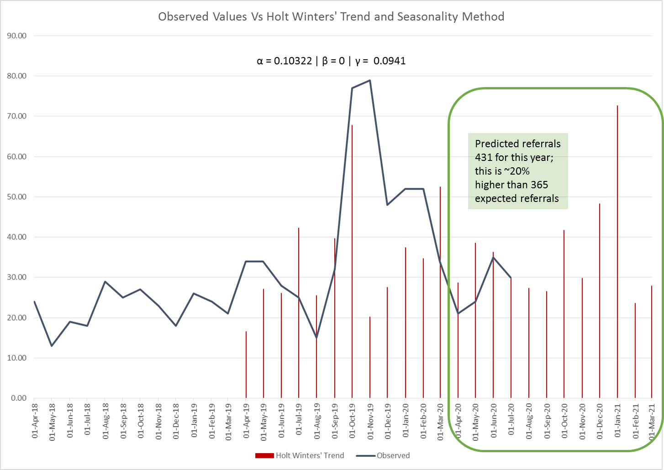

#### Graph 2

These figures do not include those patients who are coming to the end of their time within the Gender Identity Development Service (GIDS); very few are currently being referred. When a young person turns 18, a decision is made by the GIDS service in London as to whether or not they can be seen in Cardiff. With this in mind, ~90% of this cohort of patients are expected to be transferred. This new process will come in to practice from September 2020.

The current number of young people on the waiting list at GIDS is 212 (as at 7th August 2020). The ages of these are unknown, but with 90% of these expected to come through the system, over the next 5 years, it is expected to comprise of an extra ~200 patients coming through the service (this does not include future new referrals).

The referral rates have slowed for GIDS over the last 2 years (GIDS (2020)), and seem to be settling at 130 to 140 referrals per year (Table 3). As these patients will only transfer to the WGS when they reach 18, and we do not know the ages of the patients in their system, it is unknown at which point they will flow in to the system.



#### Table 3

# Capacity

### Financial Year 2019/2020

There was no capacity available to the service until September 2019 when Dr John Dean was appointed as the clinical lead. Due to training needs, capacity between the two clinicians varied, also impacted by the clinical psychologist having a second clinical commitment of providing psychological therapy. The derived capacity for the remaining 6 months of the year was 126

This capacity was abruptly reduced in March 2020 due to the impact of COVID-19. All face to face appointments were postponed and, where appropriate, were switched to telephone or video consultations; initially, we were only able to offer Gender Identity Healthcare (GIH) review, endocrine, and psychological therapy consultations. In order to be compliant with guidance on clinical practice during the COVID-19 pandemic, published by the British Association of Gender Identity Specialists, identity-related diagnostic assessments, treatment planning, hormone initiation and surgery endorsements were temporarily suspended. The team had to work together to find a system that was clinically safe for our patients. The effect of this on activity is shown in Table 5.



#### Table 5

Using the new capacity levels against activity, Graph 3 shows the cumulative effect of performance against this. It is important to note that as both clinicians were still being trained, there was always an expectation that the available capacity could fluctuate; this was to ensure the safety of the staff as well as the safety of the patients.

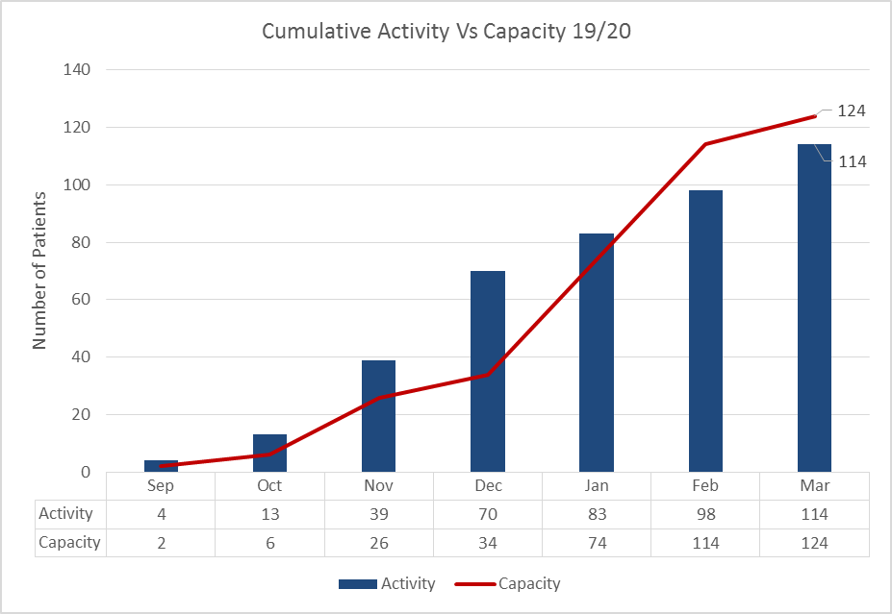

#### Graph 3

### Financial Year 2020/2021

At the beginning of the financial year, the post of Gender Specialist was recruited to. While the service still had staff redeployed (consultant psychiatrist redeployed and then retired), we were still not able to start seeing patients immediately. With that in mind, the structure of the team and capacity was affected; shielding staff required appropriate software and training to facilitate virtual consultations.

Further to discussions with information governance, it was advised that the use of Attend Anywhere software was the most secure for virtual consultations; this was made available through the health board pilot of the software.

# Current performance and benchmarking

The service was initially set up as an interim service, with the proviso that only non-complex patients were to be assessed, and endorsed, for hormone replacement therapy; surgical assessment and surgery were still to be performed in London at that time. The criteria for complexity of care has changed over the 12 months of patient contact and almost all patients are seen, with exclusions applying only to those currently incarcerated. There is also the provision of a peer support system where patients are supported while waiting for their appointment; Transgender people face substantial mental health disparities, and this population’s emotional well-being can be particularly volatile during gender transition (Hamison (2019))

|  |
| --- |
| 06. Option Appraisals |

To underpin the option appraisal below, the key principles of finance and activity have been used from the procurement for the provision of specialised gender dysphoria services for adults (NHS England, (2019)).

These are:

* Be sustainable in the medium term and long term
* Be transparent and capable of scrutiny
* Support investment in the workforce
* Match capacity and demand
* Ensure future investment is directed at service development
* Be adaptable to support new and innovative ways of service delivery

Using these principles as a foundation, the following three options have been developed:

* Option 1: Continuation of the Current Service i.e. Do Nothing
* Option 2: Phased Growth (preferred option)
* Option 3: Enhanced Phased Growth

Each of these will be described in detail to include:

* Staffing structure
* Potential Capacity
* Waiting List Implications
* Financial Implications
* Peer Support
* Conclusion

# Option 1: Continuation of the Current Service

## 1.1 Clinical Staffing structure

The current staffing structure was appointed based on the budget requested in the initial business case in 2018. A clinical lead was appointed, Dr John Dean, to provide training and clinical oversight to the service. Dr Dean would see patients with other clinicians within the context of training (to demonstrate practice or to pride direct supervision of learners) and would not usually contribute to service capacity. The structure has two clinicians providing direct clinical contacts (DCC) as well as therapeutic sessions

## 1.2 Potential Capacity

With no capacity adjustment the service could facilitate ~462 appointments. It is important to note that activity levels are not a given, variation is inevitable (NHS Improvement, Managing Variation (2020)), this principle is carried throughout.

## 

## 1.3 Waiting List Implications

When modelling the waiting list position, there is a need to include both new and follow up appointments as they will mostly be consultations to ‘sign off’ on surgery and hormones. With that in mind, the data obtained from the London GIC showed that the median number of appointments was 3, with patients having a range of 1 to 18 appointments. With further discussion, it was decided that with the range being so great, the modelling would incorporate 3 different new to follow up ratios, 1:2, 1:3 and 1:4. This principle is carried throughout.

This capacity would provide:

* 11 appointments per week, for 42 weeks of the year (the remaining 10 weeks of the year account for annual leave, study leave and conferences)
* This has been split in to 8 new and 3 follow up appointments
* Demand is initially set at 9 per week (this includes transfers from the Gender Identity Development Service (GIDS); there are 200 to transfer so have been split to 40 per year for modelling purposes), with a backlog of 1000
* There will be a 20% increase in demand for the first 3 years and a 0% increase for the final 2 years

The ensuing impact on the waiting list is shown in Graph 4.

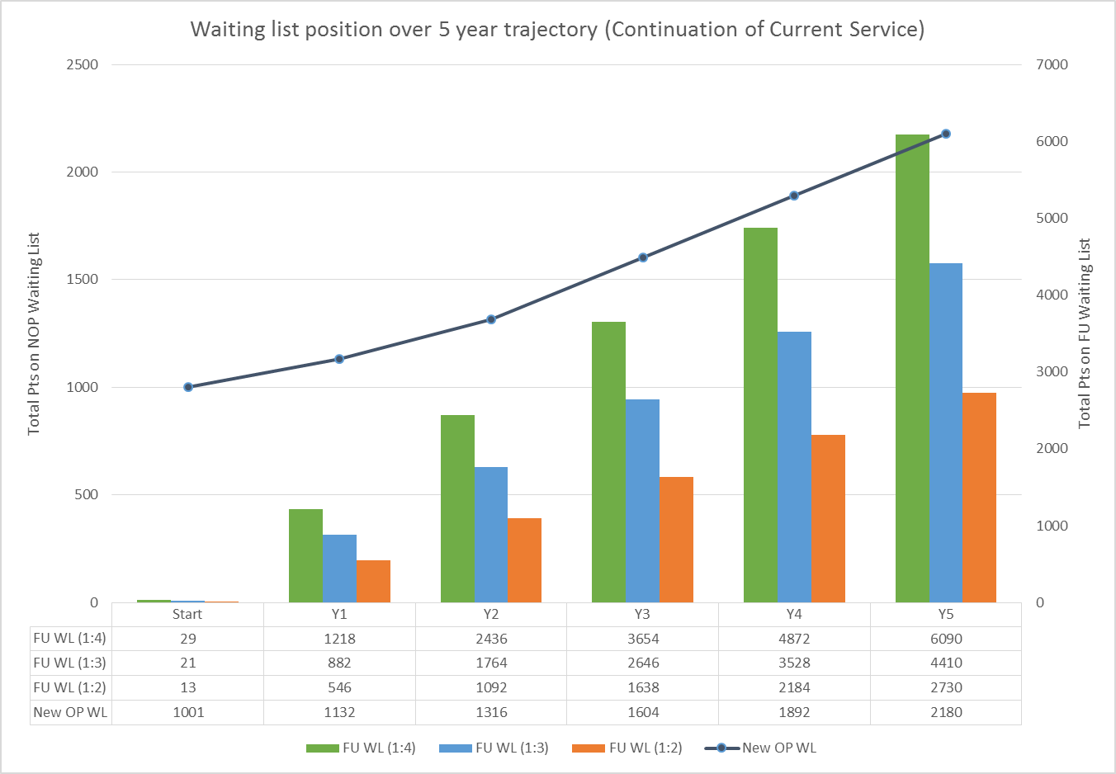

#### Graph 4

Depending on the new to follow up ratio, we will have a range of between 3,000 and 6,000 on the follow up waiting list at this level of capacity. Clearly this is not an ideal position as this will:

* Create delays between appointments
* Slow transition down
* If new outpatients are cancelled to see follow up patients then it will create a problem there

The resulting length of wait for a first new outpatient is shown in Table 9

  
Table 9

## 1.4 Financial Implications

This option mainly incurs no change, the budget for this is shown in Table 10. There would be a need for extra funding for peer support as this was funded separately in 2019/2020 financial year.

## 1.5 Peer Support

The service is extremely fortunate to have a peer to peer information and support programme in place, with Umbrella Cymru, which seeks to improve care and confidence for patients of the Welsh Gender Service; transgender people face substantial mental health disparities, and this population’s emotional well-being can be particularly volatile during gender transition (Hamison (2019)). The current provision of the support service is managed by a registered Social Worker who completes assessments and coordinates the service. Peer support is delivered by people with a lived experience of transition or gender incongruence or diversity. The service has increased representation of gender diverse people and has therefore impact positively on the experience of patients being referred to the Welsh Gender Team.

The aim of the project is to deliver the following:

* Improved
  + physical health, mental health and wellbeing
  + patient experience and reputation of welsh health boards
* Increased
  + confidence to be oneself in all areas of life
  + knowledge of social, medical, surgical legal processes
  + confidence in and satisfaction with WGT and the NHS in Wales
* Reduced
  + costs to health, social care and wider public services
  + complaints

The impact of the service has been positive and is evidenced through patient feedback (Appendix 1)

# Option 2: Phased Growth

## 2.1 Clinical Staffing Structure

This option will provide an increase in the clinical capacity that allows us to reduce the backlog of patients and to manage the ongoing demand. Historically, there have been significant challenges in recruiting and employing appropriately qualified and experienced clinicians due to lack of providers who are sufficiently knowledgeable (Joshua et al (2016)). With this in mind, a staggered approach to employing and training clinicians may be more realistic and ‘deliverable’. The staffing structures in Tables 13 and 14 will need to be flexible based on the needs of the service. Historical difficulty does not necessarily predict future recruitment of Gender Specialists, particularly with the increasing acceptability of remote consultation as appropriate for, perhaps, 85% of patients. For the first time, this enables interested clinicians that do not live within commuting distance of a Gender Dysphoria Clinic the opportunity to train in GIH without unacceptable disruption to their lives.

Each clinician that is not an experienced gender specialist (has worked full-time, or equivalent, in an NHS-commissioned Gender Dysphoria Service for at least two years) will need to complete the PGDip Gender Identity Healthcare awarded by the University of London and managed by the Royal College of Physicians. This course aims to enable participants to develop an in-depth, evidence-based understanding of gender dysphoria and healthcare for trans and gender-diverse patients, and the spectrum of clinical care. The diploma is aimed towards healthcare practitioners seeking to provide evidence of competence in the assessment, diagnosis and management of gender identity-related healthcare issues with an oversight of the programme of care. Our ability to deliver optimal trans-specific health care is severely limited by insufficient trans-specific medical education, a paucity of research that addresses the expressed needs of patients, and discriminatory behaviours in medical settings (Blotner C, Rajunov M (2018)).

The University of London has two intakes per year (currently in September and February). There is currently no limit on the number of learners that might register in each intake but, in practical terms, it would be difficult to accommodate more than 20. Each candidate must be 2 sessions/week of protected time for study and the completion of assignments. Most candidates working full-time in GIH should be able to complete the programme in 18-24 months; the maximum permissible time allowed by the University for completion is 60 months.

## 2.2 Potential Capacity

The first year should be able to facilitate ~1176 appointments and years two to five ~2310 appointments.

## 2.3 Waiting List Implications

If the staff are all in place from April 2021 the impact would be quite significant (Graph 5).

This capacity would provide:

* 28 appointments per week, for 42 weeks of the year
* This has been split in to 15 new and 13 follow up appointments
* Then 55 appointments per week, for 42 weeks of the year
* This has been split in to 17 new and 38 follow up appointments
* Demand is initially set at 9 per week (this includes transfers from the Gender Identity Development Service (GIDS); there are 200 to transfer so have been split to 40 per year for modelling purposes), with a backlog of 1000
* There will be a 20% increase in demand for the first 3 years and a 0% increase for the final 2 years

The ensuing impact on the waiting list is shown in Graph 5.

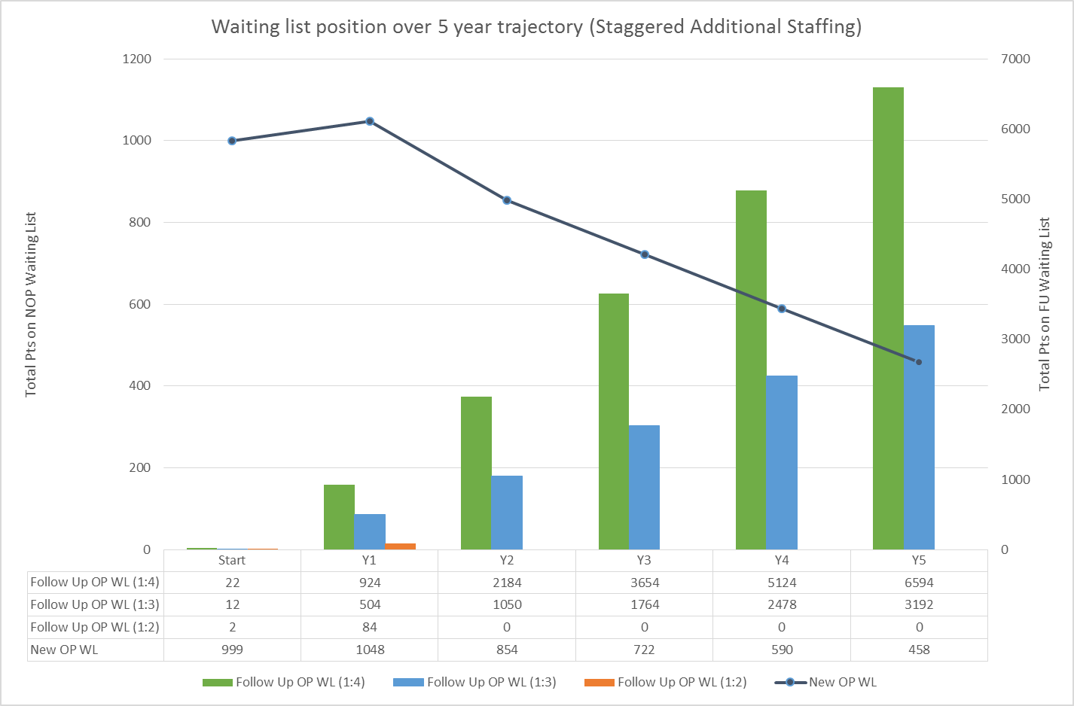

#### Graph 5

Depending on the new to follow up ratio, the range of people on the waiting list will be between 0 and 6,500 at this level of capacity. This model, however, has a much lower wait for new outpatients which will give more flexibility in how the waiting lists can be managed

The resulting length of wait for a first new outpatient is shown in Table 17



### Table 17

## 2.4 Financial Implications

There will be a cost increase in:

* Staffing
* Training
* Infrastructure
* Travel
* Conferences

## 2.5 Peer Support

Evaluation and monitoring of the service provided to date shows X% of those referred to the service take up support from Umbrella Cymru. In addition to these, Umbrella Cymru have identified X number of people who required support before being referred to the WGS, including developing knowledge, confidence and understanding of their identity and the support and clinic pathways available.

Understanding the demand for the support service, it is anticipated that the staffing structure for the service should increase to: //Insert staffing levels once known//

## 2.6 Conclusion

Discuss preferred option

# Option 3: Enhanced Phased Growth

## 3.2 Potential Capacity

The first year should be able to facilitate ~1334 appointments and years two to five ~2772 appointments.

### 3.3 Waiting List Implications

If the staff are all in place from April 2021, again the impact would be quite significant.

This capacity would provide:

* 32 appointments per week, for 42 weeks of the year
* This has been split in to 16 new and 16 follow up appointments
* Then 66 appointments per week, for 42 weeks of the year
* This has been split in to 16 new and 50 follow up appointments
* Demand is initially set at 9 per week (this includes transfers from the Gender Identity Development Service (GIDS); there are 200 to transfer so have been split to 40 per year for modelling purposes), with a backlog of 1000
* There will be a 20% increase in demand for the first 3 years and a 0% increase for the final 2 years

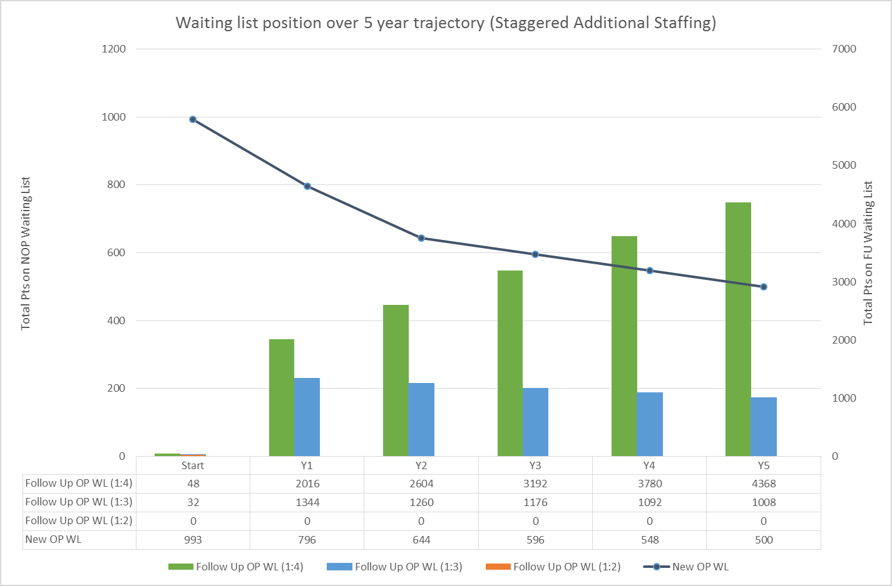

#### Graph 6

This model would allow a far better balance with the follow up waiting list, however, as the balance of the new to follow up ratio involves a high level of variation (NHS Improvement, Managing Variation (2020)), it is uncertain as to whether this level of investment, at this stage, would be prudent. The resulting length of wait for a first new outpatient is shown in Table 25



### Table 25

### 3.5 Peer Support

Evaluation and monitoring of the service provided to date shows X% of those referred to the service take up support from Umbrella Cymru. In addition to these, Umbrella Cymru have identified X number of people who required support before being referred to the WGS, including developing knowledge, confidence and understanding of their identity and the support and clinic pathways available.

Understanding the demand for the support service, it is anticipated that the staffing structure for the service should increase to: //Insert staffing levels once known//

### 3.6 Conclusion

Discuss preferred option

|  |
| --- |
| 08. Outcomes and Benefits |

Clinical effectiveness

The expansion of this service will safeguard and build upon the past 12 months of developments in trust, collaboration, and meaningful co-production with stakeholders, achieved through stakeholder engagements (9th August 2019, 13th September 2019, and 14th February 2020). Safeguarding the principles reflected in the visual minutes (attached) will ensure that continued transparency, as directed in the ‘Well-being of Future Generations (Wales) Act 2015’ is upheld.

This proposed service has the potential to significantly improve the quality and effectiveness of clinical services across Wales by continuing to provide GP’s with further knowledge and training in trans-related care, something that has been identified as desperately needed (Trans Mental Health Survey (2012)). It also has the capacity to expand the knowledge and skill base of future clinical psychologists via teaching and placements on the Doctoral programme at Cardiff University.

Health gain

This case will have a positive effect on the health related quality of life of trans and gender diverse people by providing timely diagnostic consultations, psychological support and social guidance. This community experience higher rates of discrimination and harassment when compared to cisgender people (Centre for suicide prevention (2020)) and these life stressors result in significantly poorer mental health outcomes. With almost half of trans people in Britain having attempted suicide at least once (Trans Mental Health Survey (2012)) it is vital that this service development is supported to continue to work towards providing equitable services.

When accessing gender services, treating a person for gender dysphoria reduced negative endpoints such as HIV, depression, suicidality and drug abuse (Padula et al (2015)). In accessing gender services, a person is more likely to receive support that might mitigate the negative impact of experiences of stigma and discrimination which contribute to poor mental health (Meyer, 2015: Testa, Habarth, Peta, Balsam, & Bockting, 2015).

In line with Matrics Cymru (2017) (which is based on learning from the Scottish Matrix (NES, 2015) and Improving Access to Psychological Therapies (IAPT) in England, and which has general principles that are applicable to the delivery of psychological therapy in physical health settings) we have the opportunity to reduce the inequity that trans and gender diverse people face in accessing psychological interventions that are evidence-based and designed to ‘relieve distress, improve functioning, wellbeing and quality of life’ (Matrics Cymru, 2017, p.4).

Population impact and Patient experience  
According to the ONS 2018 estimate, the population of Wales is 3,138,600 (ONS (2020)). The service is currently only seeing adults; the percentage split of adults in the population is 79% (UK Government (2020)). The range of transgender adults within our population (Zhang et al (2020)), ranges from 0.3% of the population to 0.5%. (Table 30)



#### Table 30

This therefore translates to between 7500 and 12,500 people; these are the people who would either wish to access the system, have already accessed the system, or have no desire to access the system.

The map below shows where in Wales the current patients on the waiting list reside.

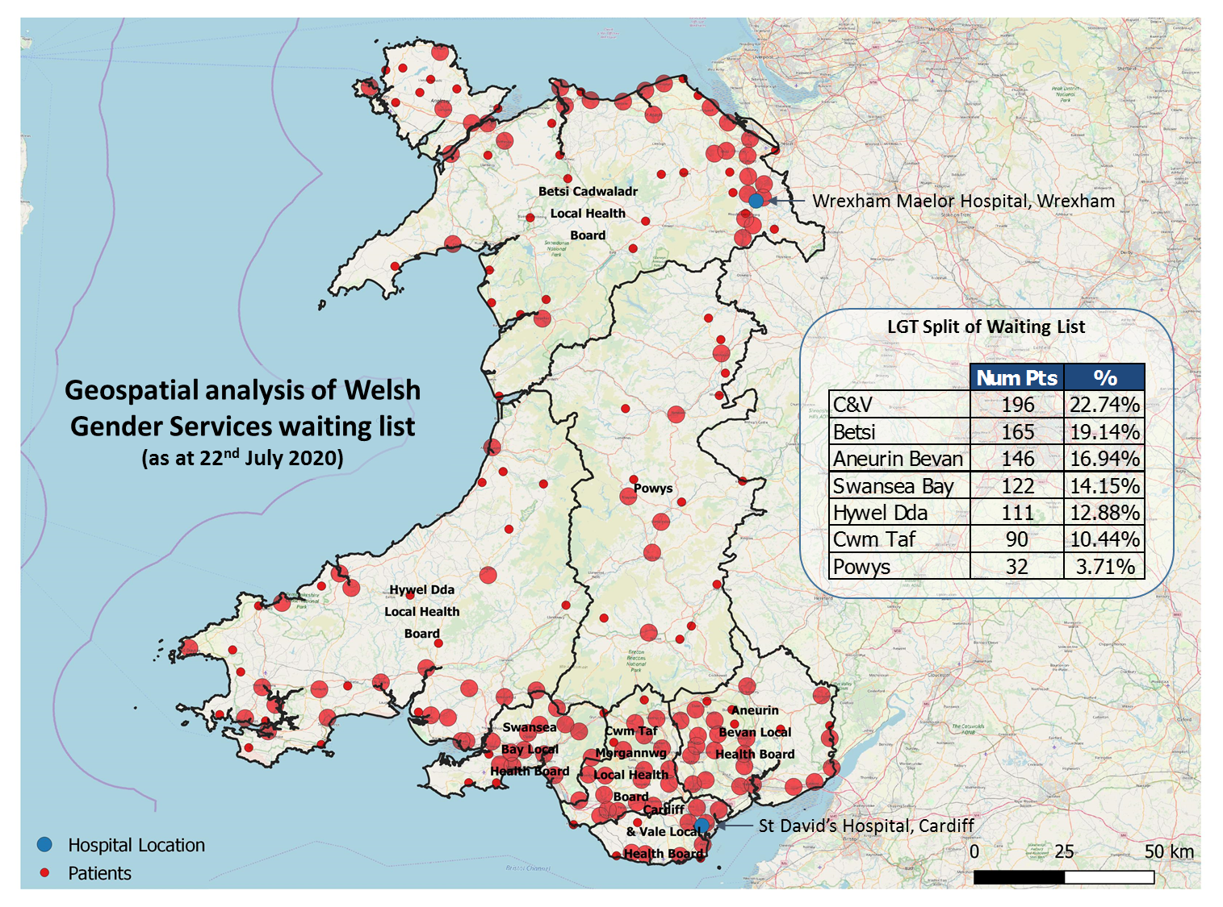Diagram 2

It is in the patient’s interest to move care closer to patients by using community hospitals as it will improve patient care (Salisbury and Purdy (2007)). With this in mind, along with the clustering of referrals in North Wales, it is clear that there is the demand for a service in North/Mid Wales; Betsi, Hwyel Dda and Powys make up 32% of the referrals.

This fits in well to the Well-being of Future Generations Act 2015, which is unique to Wales, as it requires public bodies in Wales to think about the long-term impact of their decisions, to prevent persistent problems such as climate change.

Furthermore, by moving the service to Cardiff from London, there would be an immediate saving of 29.95 metric tons of CO2 (Diagram 3) for just one appointment each (Carbon Footprint (2020)). This is based on a moderate sized family car travelling to the hospital closest to their home address.

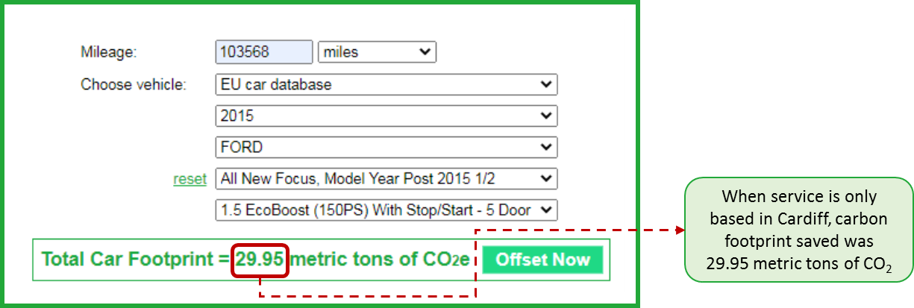

#### Diagram 3

If there were to be a second centre opened in, for example, Wrexham Maelor Hospital, this could be increased to 36.65 metric tons of CO2e

Health equality impact

This case will contribute to reducing health inequalities across the Welsh population of trans and gender diverse people, and Prudent Healthcare (2016) principles have been adopted to demonstrate this. By applying principle 1 of Prudent Healthcare, the service has collaborated with the ‘public and professionals as equal partners through co-production’ (Prudent Healthcare (2016) pg. 19). In applying principle 4 of Prudent Healthcare, this case has demonstrated the reduction of ‘inappropriate variation through evidence-based approaches’ (Prudent Healthcare (2016) pg. 19). It is vital that clinician’s within the service remain at the forefront of research and learning (through the Post Graduate Diploma for Gender Identity Healthcare Practice, attendance at BAGIS, EPATH and WPATH conferences for example) in order to contribute to and utilise this development evidence base.

Risk mitigation

Risks that this business case would be mitigate are

* Loss of service
* Underfunding of service
* Poor access to gender care services
* Unacceptably long waits for appointments

Performance

The option appraisals clearly set out how the new capacity plan would improve the waiting list position, and therefore the well-being of the patients. To ensure this is sustainable, the projections were done over 5 years to show how the investment will impact the service.

It is clear from the analysis that the increase in demand will get to a point that the service may not be sustainable; this is also impacted by the new to follow up ratio. However, as there is still so much variation in the system, these next three years of clinical capacity will be of paramount importance to identifying what the service needs going forward.

Integration and whole systems working

The peer support system has a social worker review all cases that are referred to their service. This allows them to provide support or signpost to external organisations such a local authorities. This allows the service to ensure that the patient has holistic support, not just regarding their health.

|  |
| --- |
| 09. Impact on Other Services and Engagement |

# Stakeholder engagement

There is regular contact with interested stakeholders. The service has facilitated three dedicated meetings where stakeholders were given the opportunity to listen to the clinic’s progress, but to also have input to how this would be taken forward. As a result of this, a monthly action log is maintained and provided to the stakeholders to ensure they are kept abreast of progress.

# 3rd Sector engagement

There is a contract in place for a charity organisation, Umbrella Cymru, to provide peer support to the patients of the gender service. This is managed by a social worker, and support is provided by people with lived experience. The engagement with Umbrella Cymru has been a positive in that the service is having input from an experienced with expertise in this area.

|  |
| --- |
| 10. Interdependencies |

# Local Gender Teams

The graduated model of care involves a network of clinicians who will provide an intermediate tier service between the Welsh Gender Team and Primary Care. Their role will be to prescribe, initiate and monitor hormone therapy in line with specialised guidance until the patient is optimised. Each Local Health Board will be responsible for funding and implementing this local gender service.

# Directed Enhanced Service (DES) for Maintenance Treatment in Primary Care

The enhanced service is designed to support patients who require ongoing hormone therapy after such treatment has been initiated and the patient optimised on treatment by the local gender teams. It will provide the necessary resources to practices to fund the ongoing care to patients with gender dysphoria which does not fall under the definition of essential or additional services. It will support clinicians to prescribe ongoing hormone treatment to patients with gender dysphoria in a safe and supported way, working with support from specialist and intermediate services. The drug costs and phlebotomy services for these patients are already covered by Local Health Boards and this will continue for both elements of the pathway.

NHS gender surgery providers (chest; feminising genital; masculinising genital)

This will continue to be commissioned in England; currently there is a slow return to chest and feminising surgery, with there being no known start for masculinising surgery.

# NHS fertility service providers (specialist advice on preservation of reproductive options; management of gamete harvesting and storage)

This is being provided to all patients, with North Wales patients being managed the same as South Wales patients (commissioning agreements mean North Wales patients usually go to English providers, but as this put an extra step in the referrals, South Wales agreed to take all Wales gender referrals)

# NHS speech and language therapy (SALT) service providers in LHBs (must be compliant with RCSLT competency framework)

It is hoped that the WGS will have SALT services built in so that they can be the central resource for complex patients and supporting all other health boards

|  |
| --- |
| 11. Risks |

|  |  |  |
| --- | --- | --- |
| Risk | Consequence | Mitigating Action(s) |
| No additional funding being identified for the service post March 2020 | Not able to provide capacity as stated | Case to be considered by WHSSC |
| No recurrent funding being identified to provide peer support to patients | Those that are currently receiving support will need this to be provided to by the WGS as it could cause harm to the patient | Case to be considered by WHSSC |
| Ability to recruit gender clinicians | Not able to provide capacity as stated | Employing locums in financial year 20/21 with the potential to make permanent. Providing observation sessions for clinicians wishing to enter gender services |
| Physical space in clinic | No room for people to work from or see patients | Space next to clinic has potential to be used for gender, however it is currently allocated to beds for COVID-19. Use of remote consultation for approximately 85% of GIH clinical contacts |
| Remote base of clinicians | Clinicians are unable to access patient information via systems and use of email will increase chances of information governance breaches | Provide hardware to clinicians. Improved Broadband, server and IT links. Provide productivity software for staff working off-site. Provide face-to-face consultation for patients who do not want remote consultation, who might be excluded by it, or for who, in clinicians’ judgement, it is not appropriate. |
| COVID-19 | Staff are redeployed therefore unable to run clinic | Virtual consultations already possible so some clinics may continue. Reduce clinics where this is not possible. Paradoxically, remote working is likely to increase service resilience and reported experience from other GDCs suggests that it improves experience for most patients. |
| Fluctuations in demand for new and follow up appointments | This could lead to too little capacity to cover the patients’ needs | Case to be considered by WHSSC |
| Effectiveness of LHB-commissioned LGTs | Patients do not receive support and care that LGTs are expected to provide and must, instead, be offered more follow up consultations with WGT. Will result in deterioration in new to follow up ratio and reduction in WGT capacity to see new patients. | Co-planning of capacity, training, clinical supervision, and agreement of roles and responsibilities with LHBs and WHSSC. Regular review and performance management. |
| Uptake of DES by GPs | GPs refuse to accept responsibility for ongoing care after completion of care with LGT, as the DES envisages. LGTs will need to keep affected patients under review, thus reducing their capacity to accept patients that are otherwise ready to be transferred from WGT care. This, in turn, will result in deterioration in WGT’s new to follow up ratio, and a reduction in WGT capacity to see new patients. | LHB Gender Leads to facilitate GP engagement with DES and ensure that LGTs are able to discharge patients to their registered GP for potentially lifelong care, as described in the DES. |
| Stakeholder engagement and support | The service stakeholders have always been an integral part in shaping the pathway and the service; the loss of the lived experience and insight would mean the service isn’t shaped in a suitable way for the people accessing it. | Engage with the community before the business case is finalised |

|  |
| --- |
| 12. Implementation Plans and Measurement |

# Staffing

The service is currently employing two locum consultants as future options to recruit permanently to the team; both are highly qualified in gender and will require no training. There are also two GPs that are interesting in working in gender that are observing the team over the last two quarters of 2019/2020 financial year. These will hopefully convert in to permanent members of the team, but will be required to undertake the PG Dip course. On the confirmation of funding, the recruitment process will begin in order to appoint all staff by 1st April 2021.

# Performance

There will be regular activity and waiting list monitoring; this will cover both clinical and peer support services. This will allow the team to follow progress of any increase in demand or fluctuations in the new to follow up ratio.

For this service, it is extremely important that patient feedback and complaints are regularly reviewed to ensure that it is fit for purpose. There has always been stakeholder engagement, and that will continue, with patient feedback included. The current patient feedback questionnaire is based on what is used by the London GIC (Appendix 20). Going forward, however, the UK wide psychology peer group are looking at ways of collaborative working to collect information on patient satisfaction; the participation of the WGT consultant psychologist will ensure that this is available to be used by the WGS.

# Horizon Scanning

Over the course of the next three years, monitoring of activity, demand, capacity and staffing requirements will allow for planning for the next iteration of funding. Through the process of performance managing the service, it will allow for improved modelling of how the service needs to be driven forward.

# Proposed project plan

Should the confirmation of funding be made available, the Diagram 4 shows how it will be implanted and monitored over the next three years.



#### Diagram 4

|  |
| --- |
| 13. COVID-19 |

With the uncertainties surrounding service provision during the pandemic, the COVID-19 recovery plan was developed as shown in Diagram 5

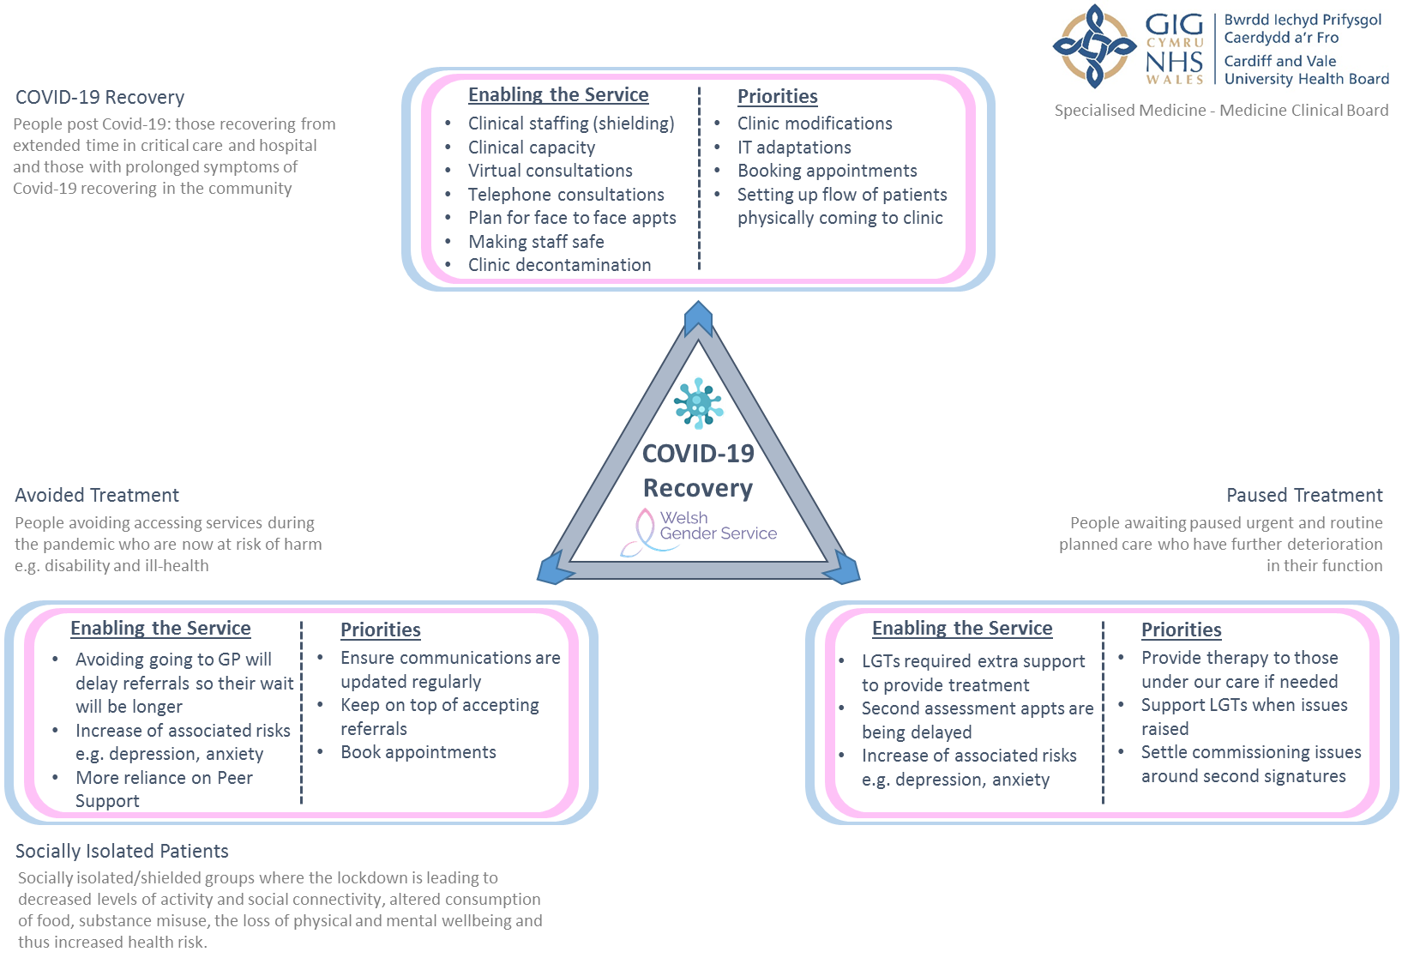  
Diagram 5

|  |
| --- |
| 13. References |

Bailey, L., J. Ellis, S. and McNeil, J.  (2014) "Suicide risk in the UK trans population and the role of gender transition in decreasing suicidal ideation and suicide attempt", Mental Health Review Journal, Vol. 19 No. 4, pp. 209-220. <https://doi.org/10.1108/MHRJ-05-2014-0015>

Bauer, Greta R., et al. (2013) "Suicidality among trans people in Ontario: Implications for social work and social justice / La suicidabilité parmi les personnes trans en Ontario : Implications en travail social et en justice sociale." Service social, volume 59, number 1, 2013, p. 35–62. <https://doi.org/10.7202/1017478ar>

Blotner C, Rajunov M (2018) Engaging transgender patients: using social media to inform medical practice and research in transgender health, Transgender Health 3:1, 225–228, DOI: 10.1089/trgh.2017.0039.

Carbon Footprint (2020) Available at: https://www.carbonfootprint.com/calculator.aspx, Accessed 22nd July 2020

Centre for suicide prevention (2020) https://www.suicideinfo.ca/resource/transgender-people-suicide/ accessed , Accessed 11th August 2020

Fielding J, Bass C. (2018) Individuals seeking gender reassignment: marked increase in demand for services. BJPsych Bull. 2018 Oct;42(5):206-210. doi: 10.1192/bjb.2018.30. Epub 2018 Jun 12. PMID: 29893661; PMCID: PMC6189985.

Gender Identity Development Service (2020) Available at: https://gids.nhs.uk/number-referrals, Accessed 7th August 2020

Haimson, Oliver L (2019) Mapping gender transition sentiment patterns via social media data: toward decreasing transgender mental health disparities, Journal of the American Medical Informatics Association, Volume 26, Issue 8-9, August/September 2019, Pages 749–758, <https://doi.org/10.1093/jamia/ocz056>

Matrics Cymru (2017) http://www.1000livesplus.wales.nhs.uk/sitesplus/documents/1011/Matrics%20Cymru%20%28CM%20design%20-%20DRAFT%2015%29.pdf, Accessed 1st August 2020

Meyer, I.H. (2015) Resilience in the study of minority stress and health of sexual and gender minorities. Psychology of Sexual Orientation and Gender Diversity, 2(3), 209-213.

NHS England (2019) Procurement for the provision of Specialised Gender Dysphoria Services for Adults (Non-Surgical), Invitation to Tender for Lot 1 – Services of a Gender Dysphoria Clinic for Adults, Project ref: PR002114

NHS Improvement, Managing Variation (2020) Available at: https://improvement.nhs.uk/documents/2179/managing-variation.pdf , Accessed 26th June 2020

Office for National Statistics (2020) Available at: https://www.ons.gov.uk/peoplepopulationandcommunity/populationandmigration/populationestimates, Accessed 16th June 2020

Padula, W.V., Heru, S. & Campbell, J.D. (2016) Societal Implications of Health Insurance Coverage for Medically Necessary Services in the U.S. Transgender Population: A Cost-Effectiveness Analysis. J GEN INTERN MED 31, 394–401 (2016). <https://doi.org/10.1007/s11606-015-3529-6>

Prudent Healthcare (2016) https://gov.wales/sites/default/files/publications/2019-04/securing-health-and-well-being-for-future-generations.pdf , Accessed 11th August 2020

Qi Zhang, Michael Goodman, Noah Adams, Trevor Corneil, Leila Hashemi, Baudewijntje Kreukels, Joz Motmans, Rachel Snyder & Eli Coleman (2020) Epidemiological considerations in transgender health: A systematic review with focus on higher quality data, International Journal of Transgender Health, 21:2, 125-137, DOI: 10.1080/26895269.2020.1753136

Safer JD, Coleman E, Feldman J, et al (2016) Barriers to healthcare for transgender individuals. Curr Opin Endocrinol Diabetes Obes. 2016;23(2):168-171. doi:10.1097/MED.0000000000000227

Salisbury C, Purdy S. (2007) Providing care closer to home. BMJ. 2007;335(7625):838. doi:10.1136/bmj.39371.523171.80

Sonja J. Ellis, Louis Bailey & Jay McNeil (2015) Trans People's Experiences of Mental Health and Gender Identity Services: A UK Study, Journal of Gay & Lesbian Mental Health 19:1, 4-20, DOI: 10.1080/19359705.2014.960990

Testa, R. J., Habarth, J., Peta, J., Balsam, K., & Bockting, W. (2015) Development of the Gender Minority Stress and Resilience Measure. Psychology of Sexual Orientation and Gender Diversity, 2(1), 65–77. <https://doi.org/10.1037/sgd0000081>

Trans Mental Health Survey (2012) https://www.gires.org.uk/wp-content/uploads/2014/08/trans_mh_study.pdf , Accessed 11th August 2020

UK Government (2020) Available at: https://www.ethnicity-facts-figures.service.gov.uk/uk-population-by-ethnicity/demographics/age-groups/latest, Accessed 16th June 2020

Virupaksha HG, Muralidhar D, Ramakrishna J (2016) Suicide and Suicidal Behavior among Transgender Persons. Indian J Psychol Med. 2016;38(6):505-509. doi:10.4103/0253-7176.194908

|  |
| --- |
| Appendix 1 |

### Peer Support Patient feedback

### Patient 1 “My experiences with Umbrella have only been amazing. From the initial non-intrusive hour long phone call to the home visits and advice from your good self. From helping me to sort my name change to finding a group that i could meet up with and not feel so isolated. Then with the follow up calls from other Transgender people who were hired by your organisation really helped to clarify certain things as well. It’s really good to know you are still there helping people. I really appreciated you for sure.”

Patient 2  
“The staff at Umbrella Cymru have provided me with consistent support throughout my transition. Everyone has been kind, understanding and supportive during what has been one of the most tumultuous times of my life. Transitioning can be a scary process, especially if you don’t know where to begin or even what your rights are; Umbrella have been amazing at not only providing me with the information I’ve needed but also with providing emotional support throughout the process. Nick has been amazing at ensuring that my needs have been met and has always been helpful and supportive whenever I’ve reached out.

I had a lot of anxiety surrounding my first appointment with the gender clinic, but the staff were all very friendly and have been more than happy to help me and facilitate my transition needs. I can honestly say that without the support of Umbrella Cymru, I would have struggled to find the information and support I needed throughout my transition. Nick and the team provide an invaluable service and I’m truly grateful for the support they have given me.”

### Patient 3

The NHS have not been helpful. But now, we have finally made contact with both Umbrella Cymru and the Welsh Gender Team and nobody has judged us or made us feel uncomfortable. One day our GP practice will have more understanding of trans youth and hopefully can be more helpful to families like ours. Thank you for your support.

|  |
| --- |
| Appendix 2 |

# Welsh Gender Services

## Patient Satisfaction Questionnaire

We would be grateful for your thoughts about attending our clinic to help further improve our service. Please use a ‘marks out of five’ system by circling the right number, where 1 is very dissatisfied, and 5 very satisfied. If the question is not relevant please circle (N/A). Please add any further comments at the back of the questionnaire.

|  |  |  |  |  |  |  |  |
| --- | --- | --- | --- | --- | --- | --- | --- |
| Question | | Very Dissatisfied | A bit Dissatisfied | Neither satisfied or dissatisfied | A bit satisfied | Very Satisfied | Not to do with me |
| 1 | How satisfied are you with time of day of your appointment? | 1 | 2 | 3 | 4 | 5 | n/a |
| 2 | How satisfied are you with the wait for your first appointment? | 1 | 2 | 3 | 4 | 5 | n/a |
| 3 | How satisfied are you with how often your appointments happen? | 1 | 2 | 3 | 4 | 5 | n/a |
| 4 | How satisfied are you with our support to you? | 1 | 2 | 3 | 4 | 5 | n/a |
| 5 | How satisfied are you with our support for people close to you? | 1 | 2 | 3 | 4 | 5 | n/a |
| If you are having hormone therapy: | | | | | | | |
| 6 | How satisfied are you with the information we have given you? | 1 | 2 | 3 | 4 | 5 | n/a |
| 8 | How satisfied are you with the care we provide for hormone therapy? | 1 | 2 | 3 | 4 | 5 | n/a |
| If you have accessed support through XIST, how did you find: | | | | | | | |
| 9 | Support before the appointment | 1 | 2 | 3 | 4 | 5 | n/a |
| 10 | Meet and greet at the appointment | 1 | 2 | 3 | 4 | 5 | n/a |
| 11 | Ease obtaining further support | 1 | 2 | 3 | 4 | 5 | n/a |
| 12 | Ongoing support post appointment | 1 | 2 | 3 | 4 | 5 | n/a |
| How satisfied are you with your main clinician: | | | | | | | |
| 13 | Friendly and courteous manner | 1 | 2 | 3 | 4 | 5 | n/a |
| 14 | The way you have been listened to | 1 | 2 | 3 | 4 | 5 | n/a |
| 15 | The way they have supported you | 1 | 2 | 3 | 4 | 5 | n/a |
| 16 | Their knowledge and understanding about gender | 1 | 2 | 3 | 4 | 5 | n/a |
| How satisfied are you with the Administration: | | | | | | | |
| 17 | Friendly and courteous manner | 1 | 2 | 3 | 4 | 5 | n/a |
| 18 | The way your phone calls are taken | 1 | 2 | 3 | 4 | 5 | n/a |
| 19 | The ease of making appointments | 1 | 2 | 3 | 4 | 5 | n/a |
| 20 | The way your privacy is dealt with | 1 | 2 | 3 | 4 | 5 | n/a |
| 21 | How satisfied are you with your overall care at this service: | 1 | 2 | 3 | 4 | 5 | n/a |
| Any other comments about the service: | | | | | | | |
| 22 | What do we do well? | | | | | | |
| 23 | What could we do better? | | | | | | |

## Thank you for taking the time to complete this questionnaire